EX NO: 2a | GENERATION AND ANALYSIS OF FREQUENCY MODULATED (FM) SIGNALS USING MATLAB
DATE:

Objectives
(i) To generate a Frequency Modulated (FM) signal using MATLAB by varying the frequency of a high-frequency carrier in accordance with the amplitude of the message signal and to observe the resulting waveform in the time domain.
(ii) To analyze the frequency spectrum of the generated FM signal using FFT and identify the carrier component, sideband frequencies, and the bandwidth of the FM signal based on Carson's rule.

Objective 1: To generate a Frequency Modulated (FM) signal using MATLAB by varying the frequency of a high-frequency carrier in accordance with the amplitude of the message signal and to observe the resulting waveform in the time domain.

PROGRAM (MATLAB CODE)
clc;
clear;
close all;
Am=1;
Ac=1;
fm=5;
fc=50;
beta=5;
kp=5;
fs=1000;
t=0:1/fs:1;
m = Am*cos(2*pi*fm*t); % Message signal
c = Ac*cos(2*pi*fc*t); % Carrier signal
fm_sig = Ac*cos(2*pi*fc*t + beta*sin(2*pi*fm*t)); % FM
subplot(4,1,1), plot(t,m), title('Message Signal')
subplot(4,1,2), plot(t,c), title('Carrier Signal')
subplot(4,1,3), plot(t,fm_sig), title('FM Signal')

Procedure:
- Open MATLAB and create a new script file.
- Clear the MATLAB workspace, command window, and close all existing figure windows using:
clc; clear; close all;
- Define the message signal parameters:
- Message amplitude A_{m} =1
- Message frequency f_{m}=5Hz
- Define the carrier signal parameters:
- Carrier amplitude A_{c}=1
- Carrier frequency f_{c} =50Hz
- Set the modulation index β=5and sampling frequency fs=1000Hz.
- Generate the time vector from 0 to 1 second with a sampling interval of 1/fs:
t = 0:1/fs:1;
- Generate the message signal using:
m = Am*cos(2*pi*fm*t);
This produces a low-frequency sinusoidal signal that acts as the modulating signal.
- Generate the carrier signal using:
c = Ac*cos(2*pi*fc*t);
This produces a high-frequency sinusoidal carrier.
- Generate the Frequency Modulated (FM) signal using:
fm_sig = Ac*cos(2*pi*fc*t + beta*sin(2*pi*fm*t));
Here, the instantaneous frequency of the carrier varies according to the amplitude of the message signal.
- Plot the message signal using:
subplot(4,1,1), plot(t,m), title('Message Signal')
- Plot the carrier signal using:
subplot(4,1,2), plot(t,c), title('Carrier Signal')
- Plot the generated FM signal using:
subplot(4,1,3), plot(t,fm_sig), title('FM Signal')
- Execute the program and observe the waveforms of the message signal, carrier signal, and FM signal.
- Analyze the FM waveform and note that the frequency of the carrier varies according to the amplitude of the message signal while the amplitude of the FM signal remains constant.

OUTPUT (GRAPH)
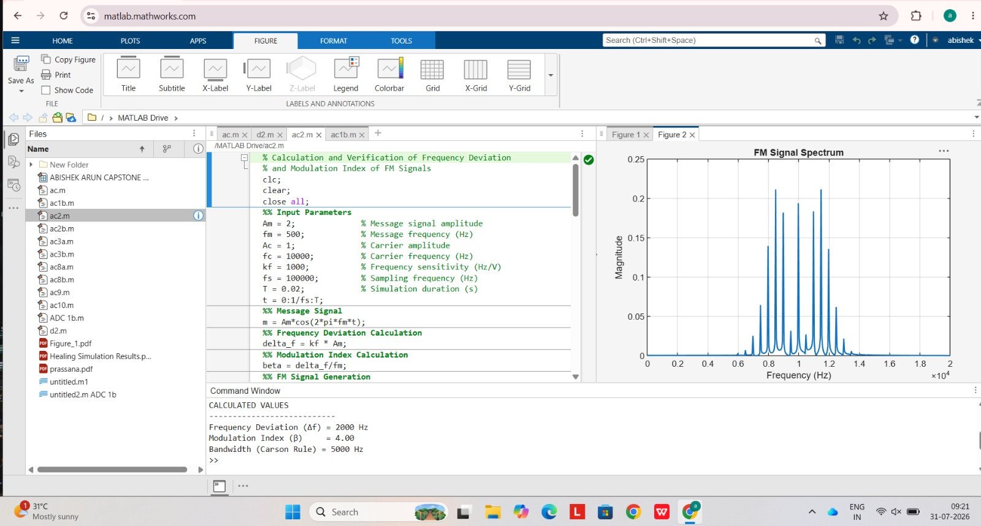
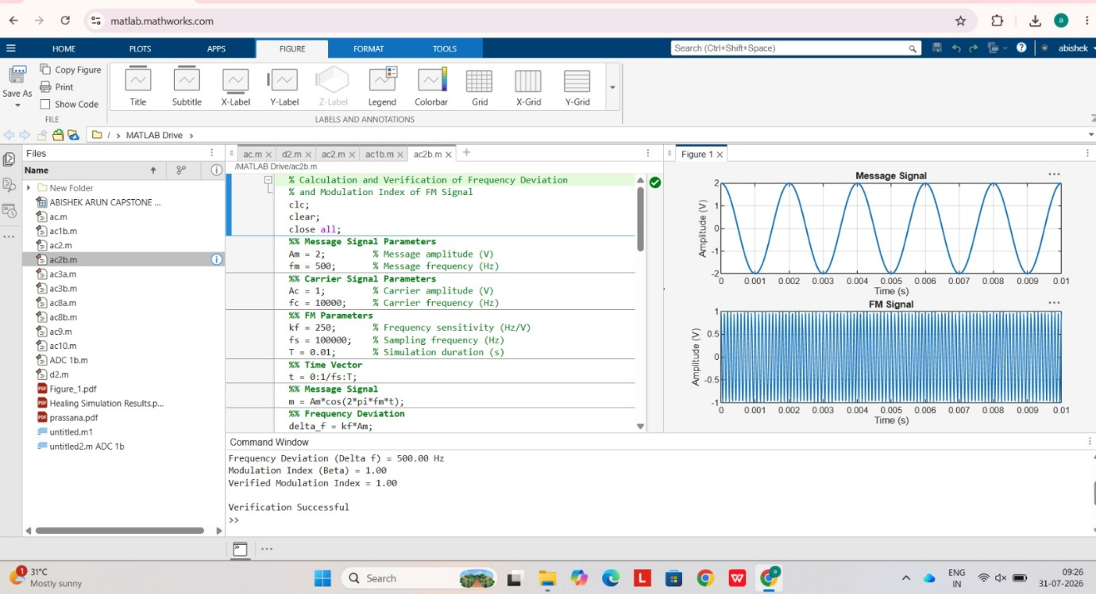

Result
The Frequency Modulated (FM) signal was successfully generated using MATLAB, and the time-domain waveforms of the message signal, carrier signal, and FM signal were observed and analyzed.

